Login page



Registration

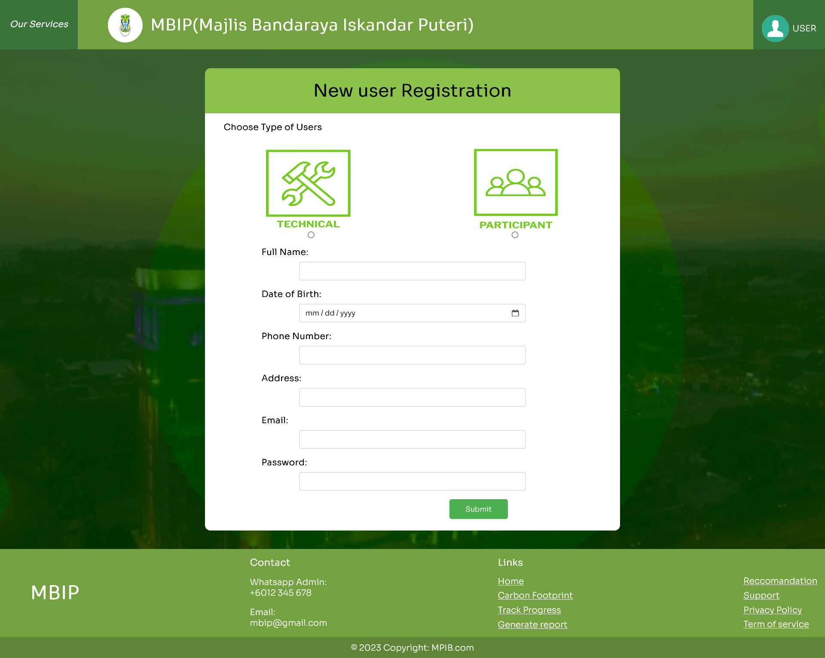

Homepage without login

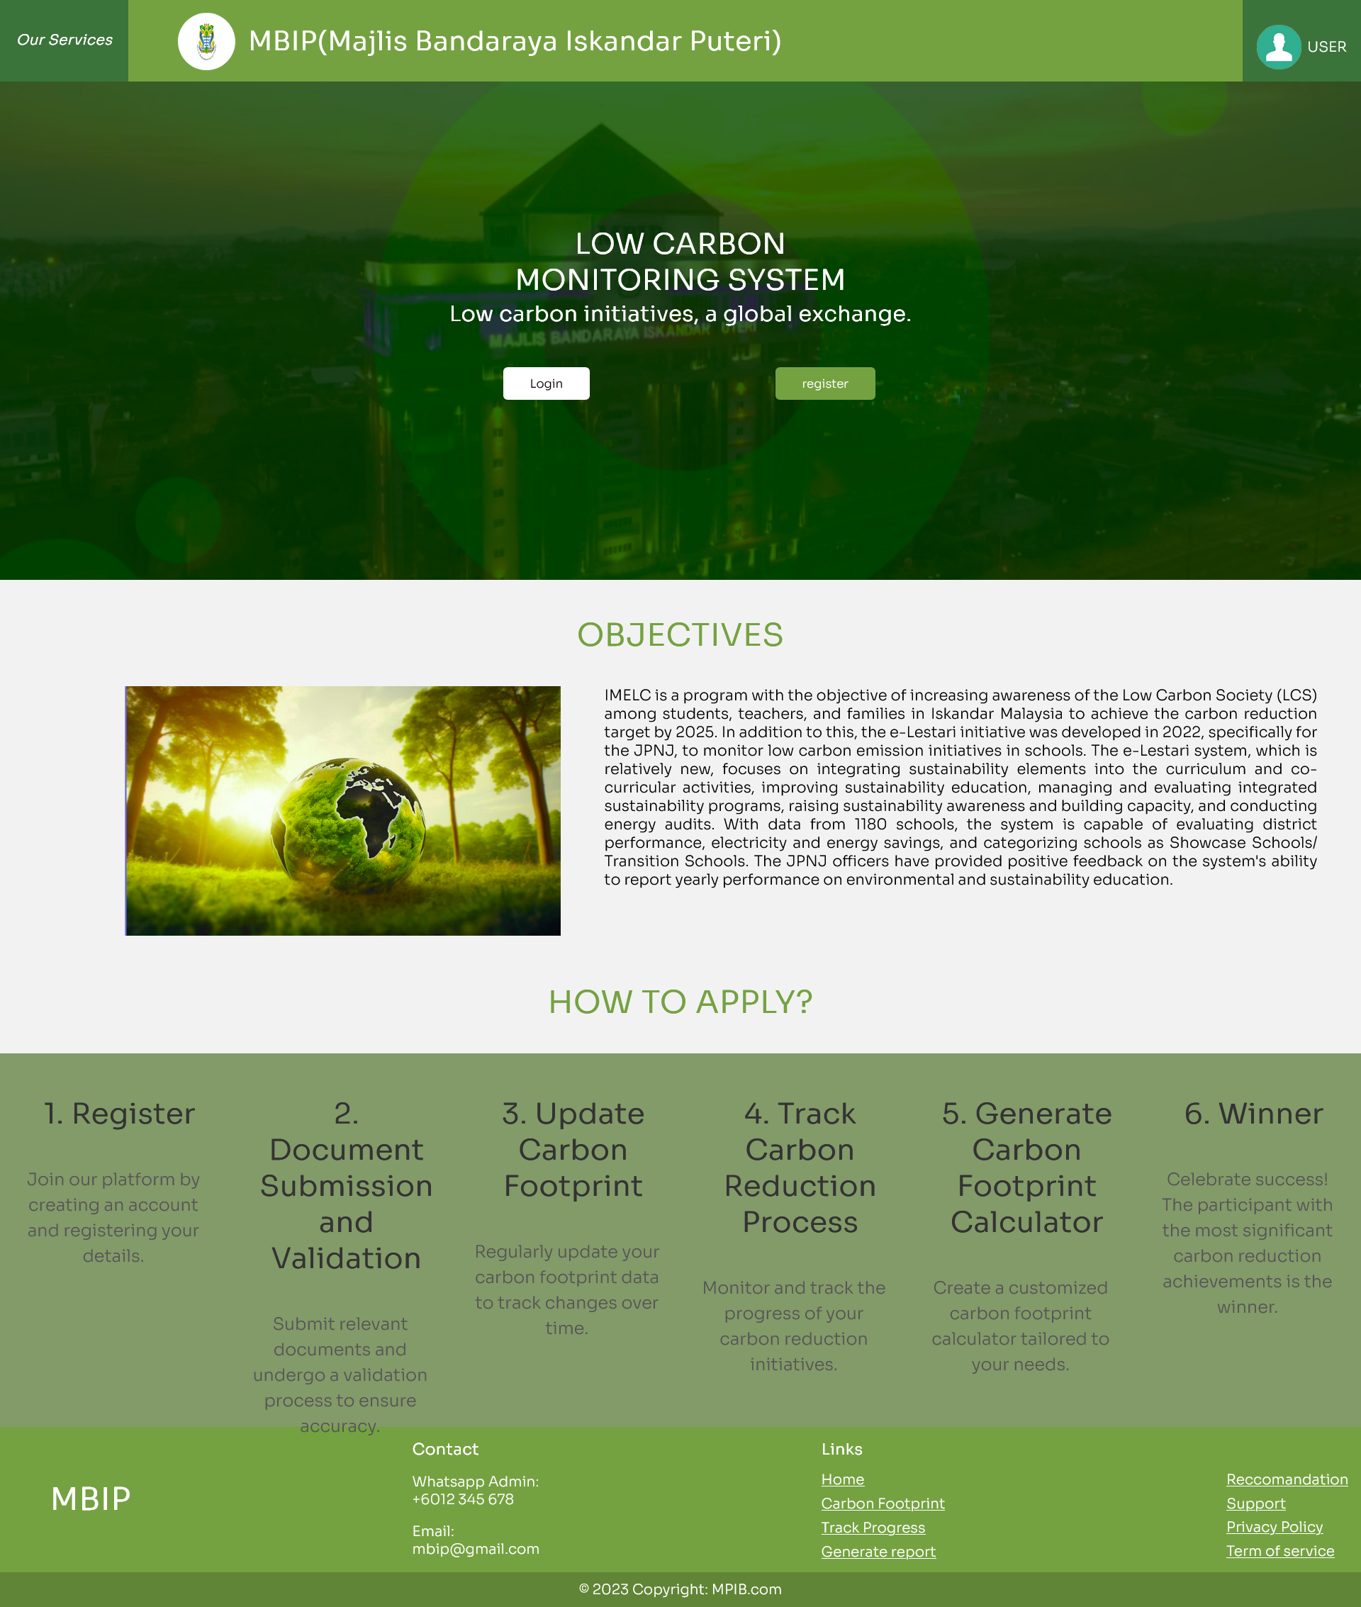

Admin view

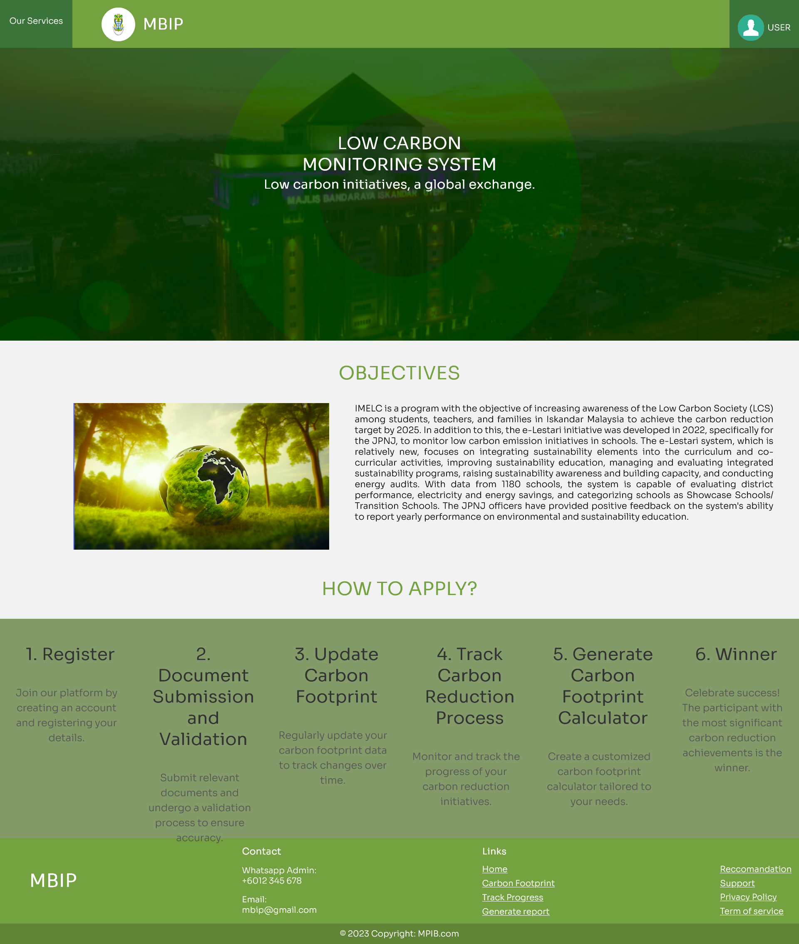

Add activity

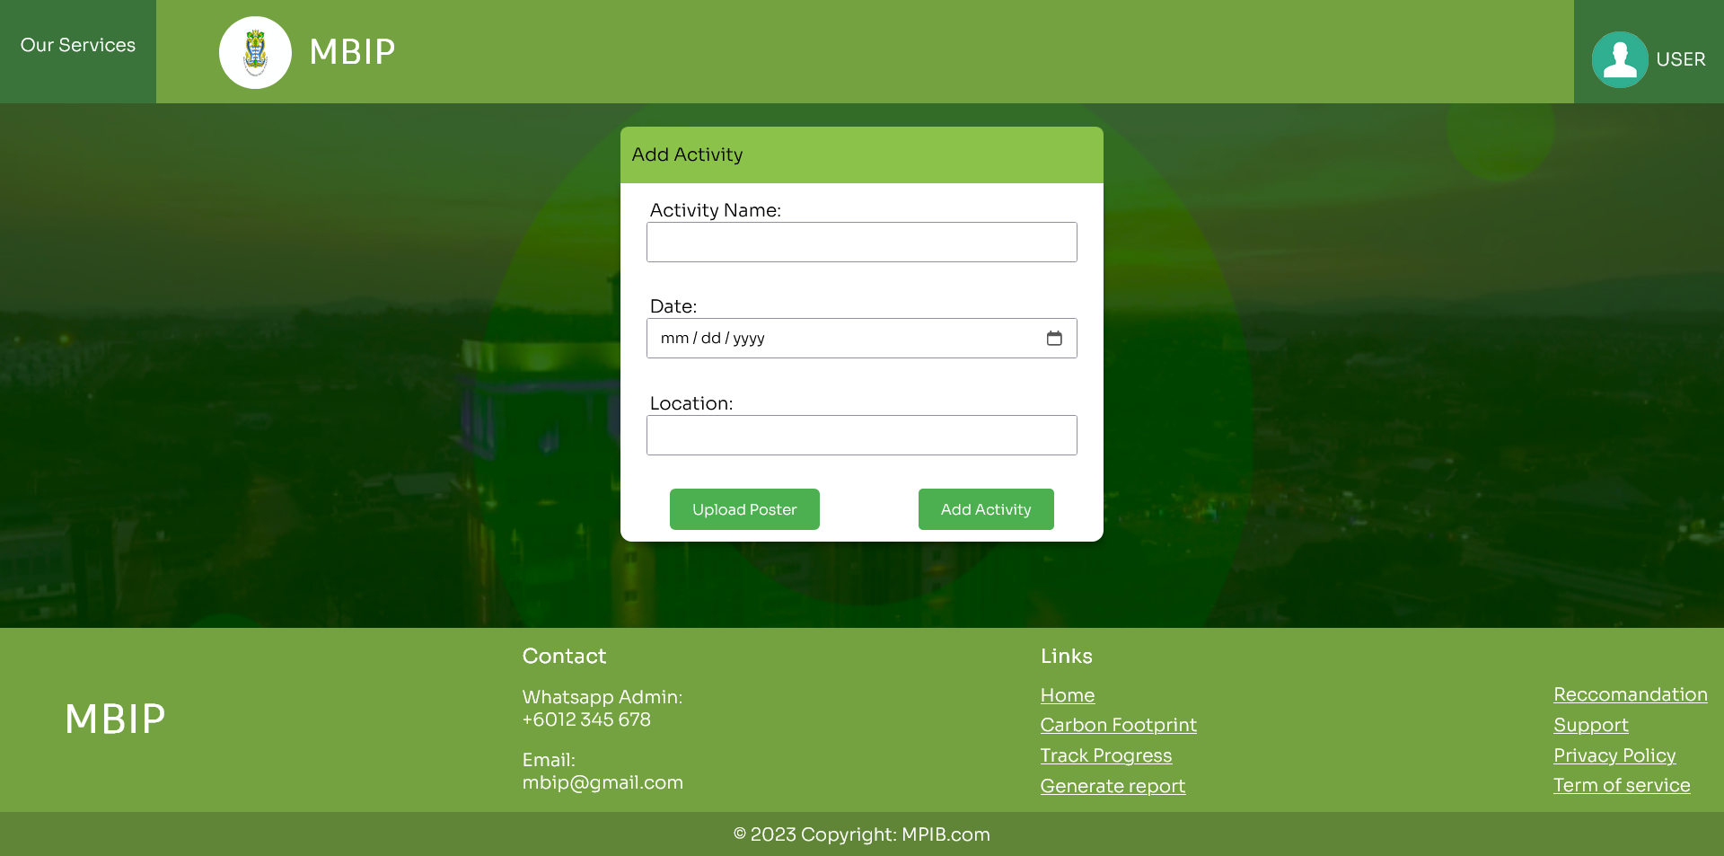

View activity

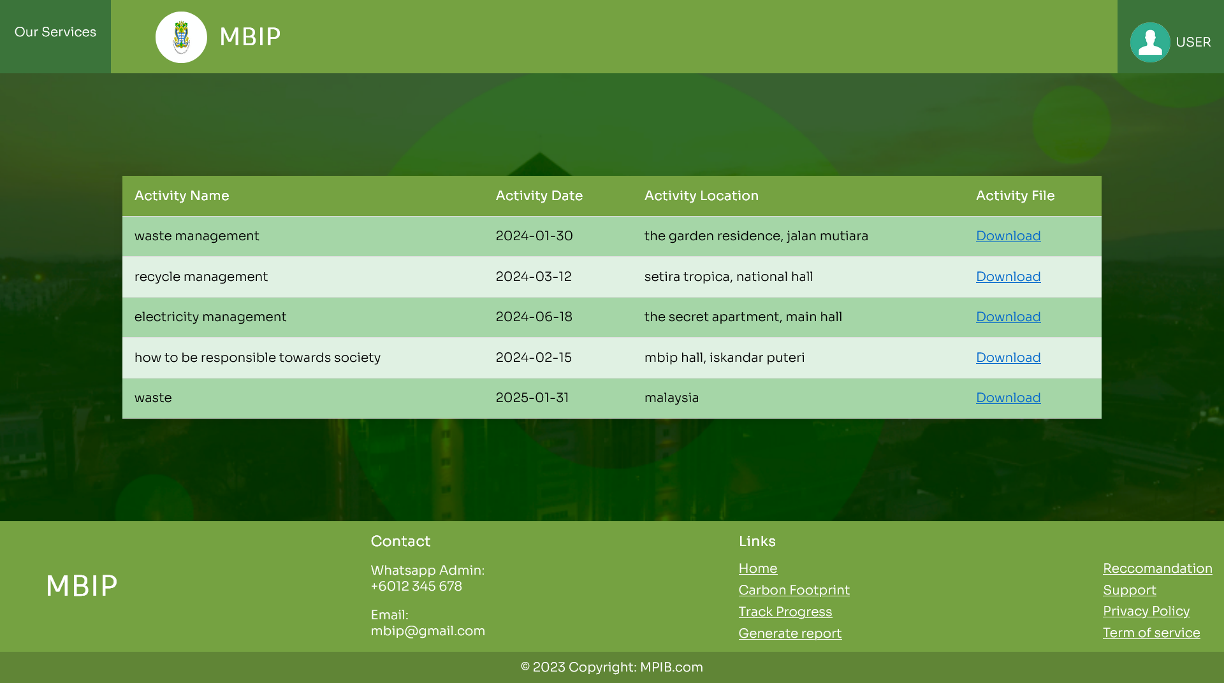

View bill approval

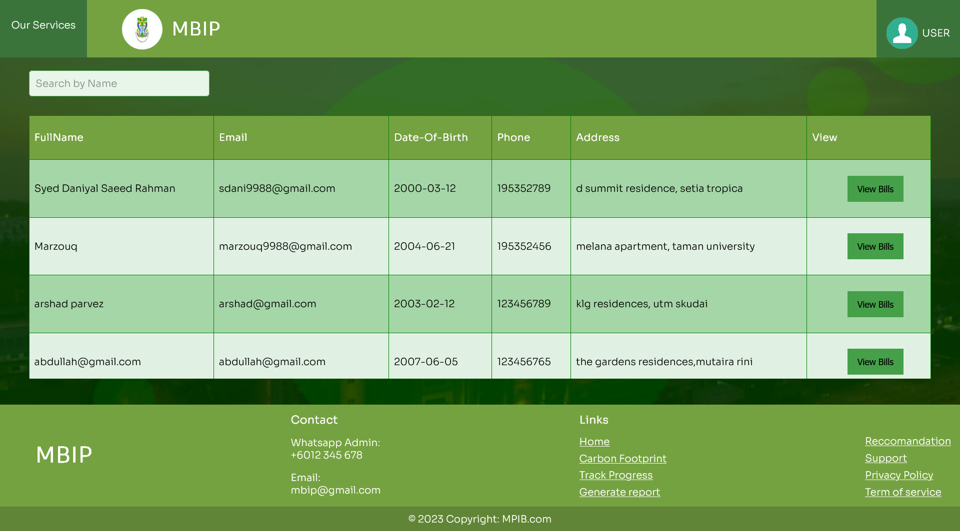

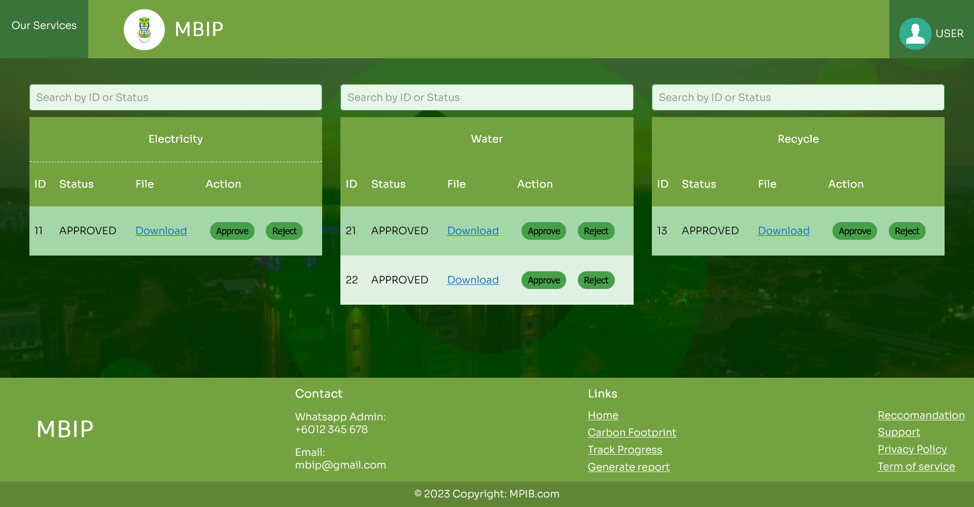

Generate report

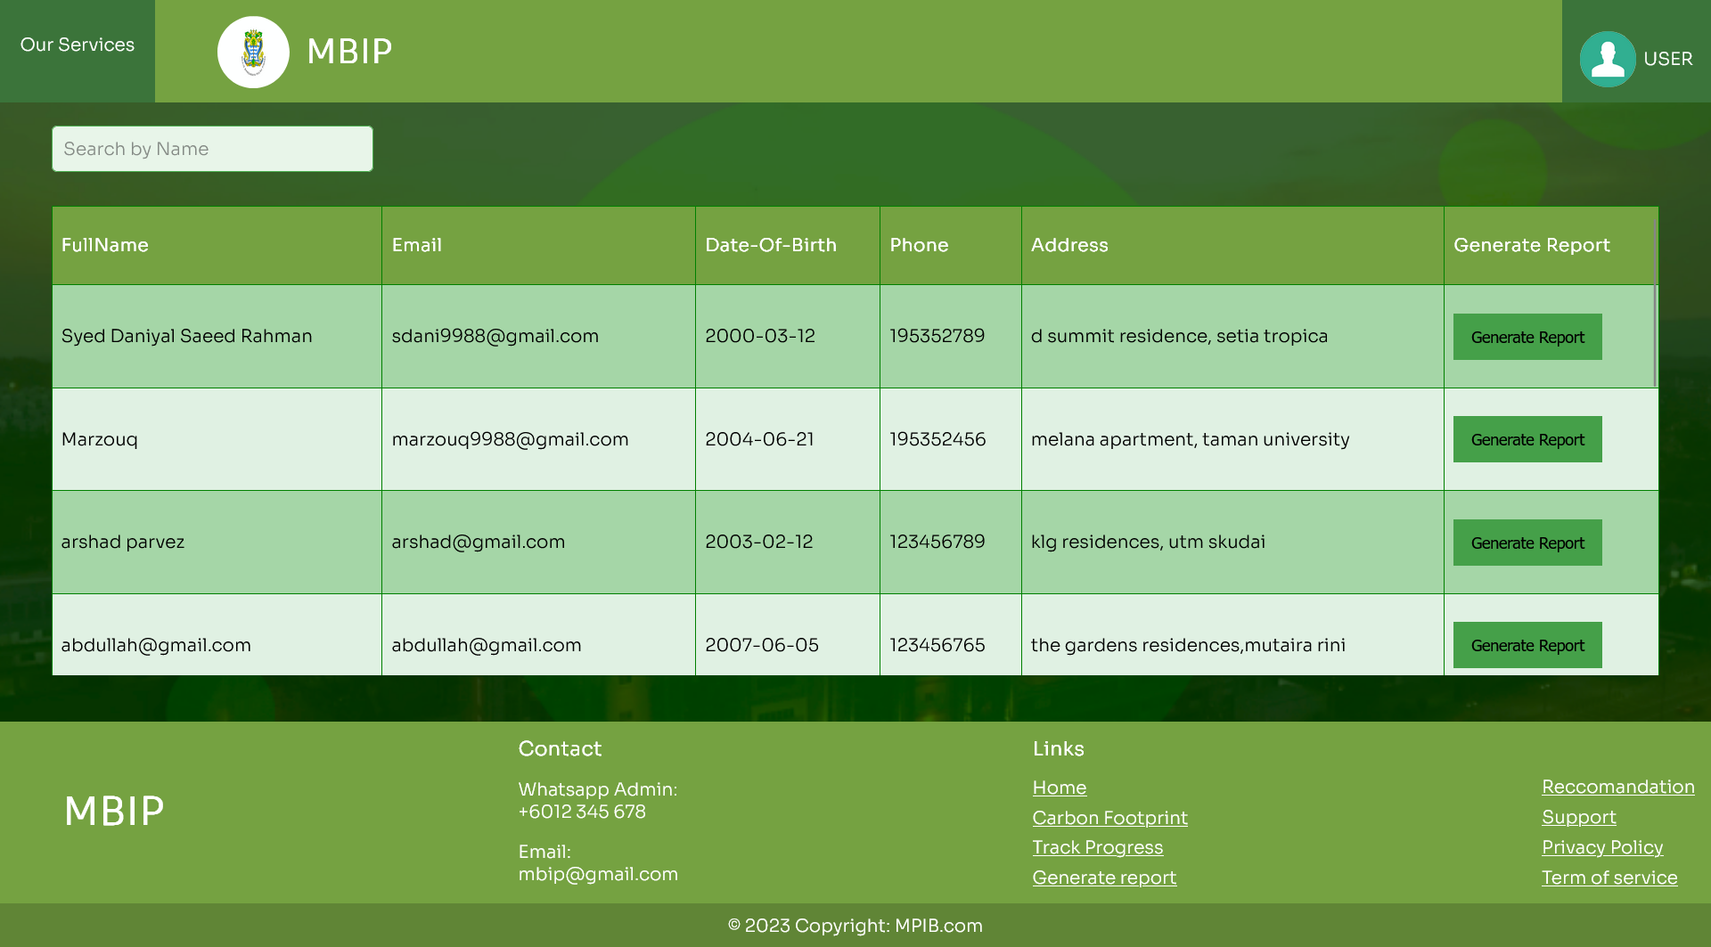

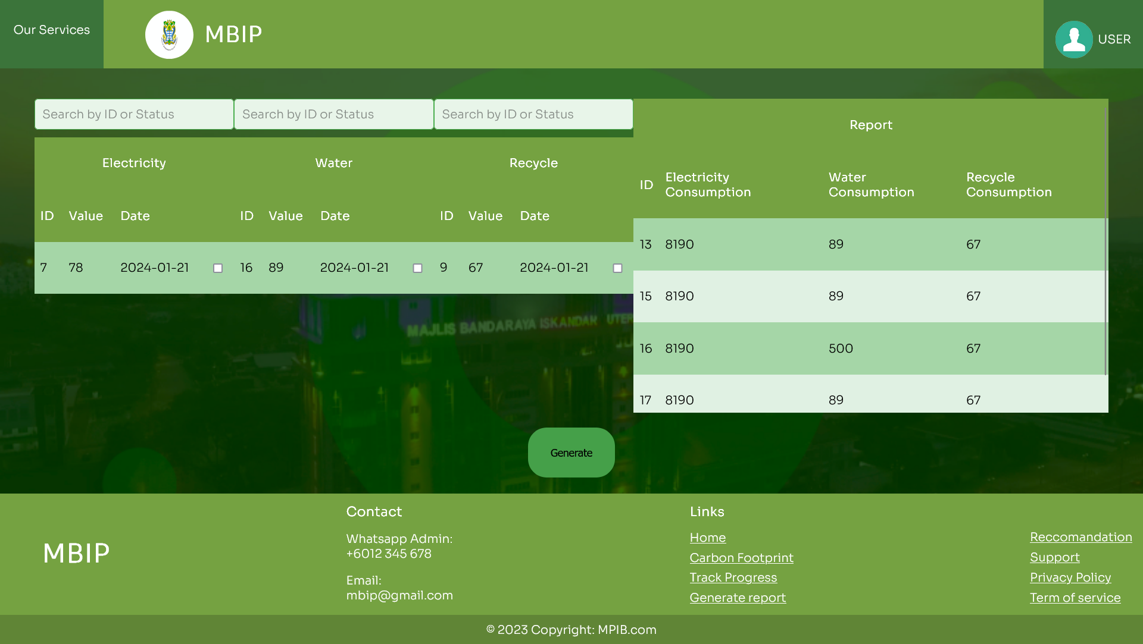



Customer view

Add waste consumption

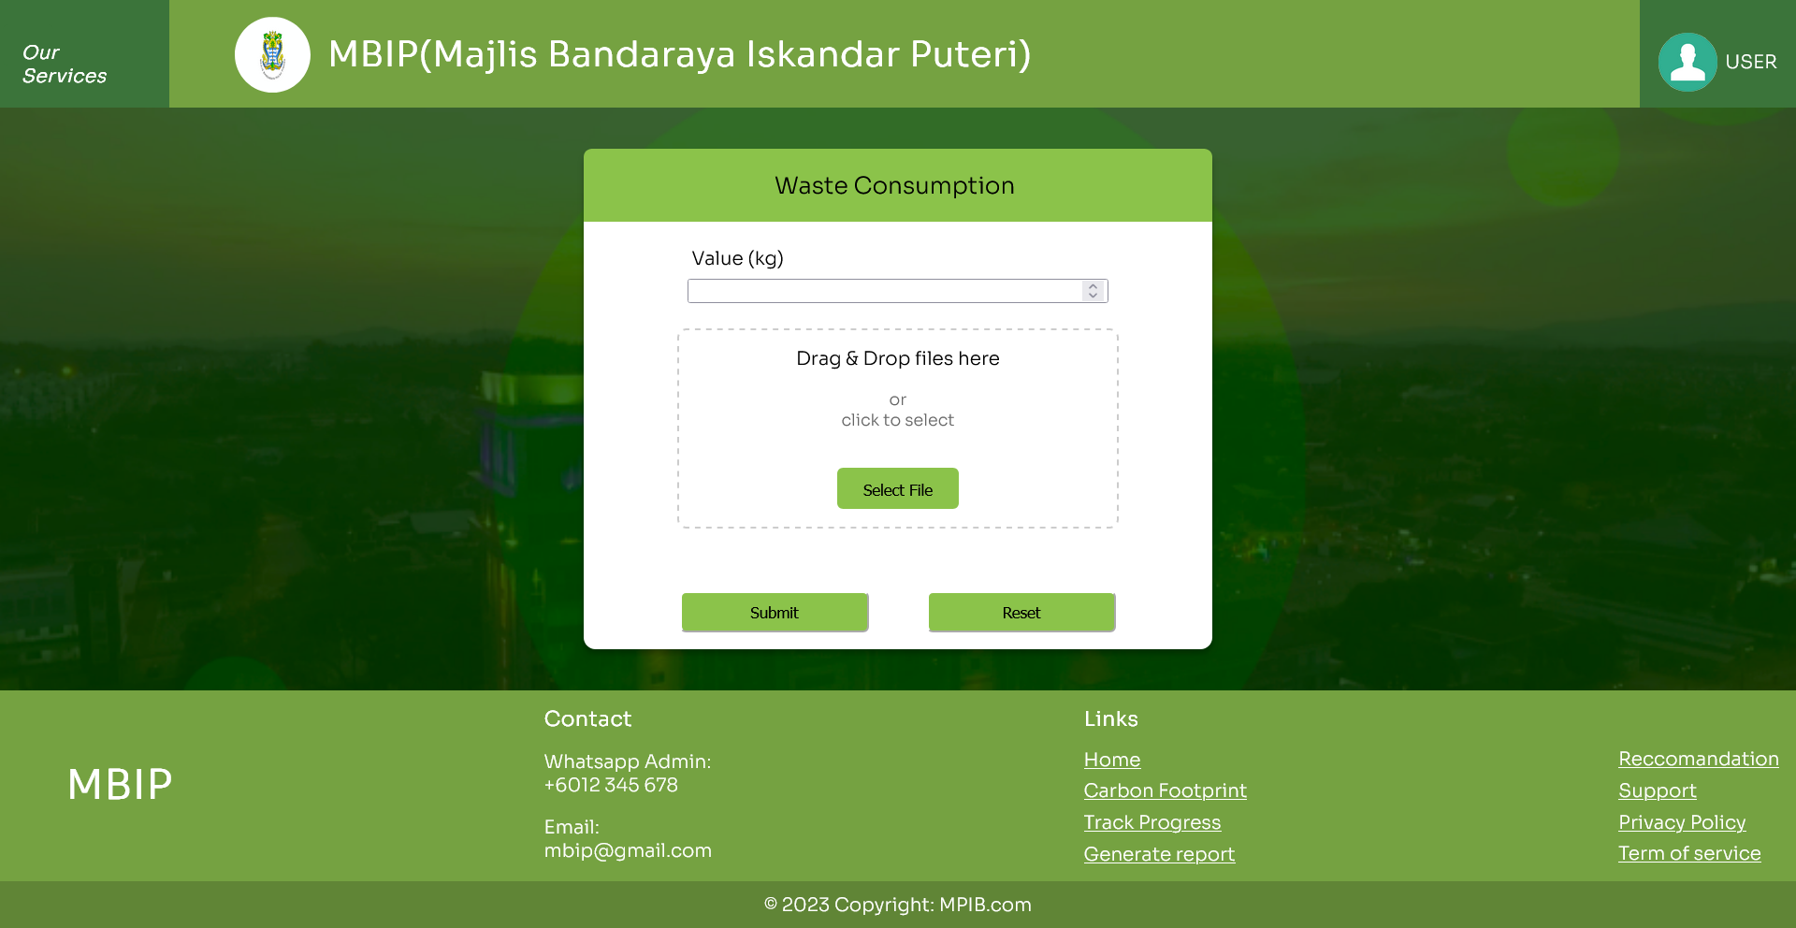



Add electricity consumption

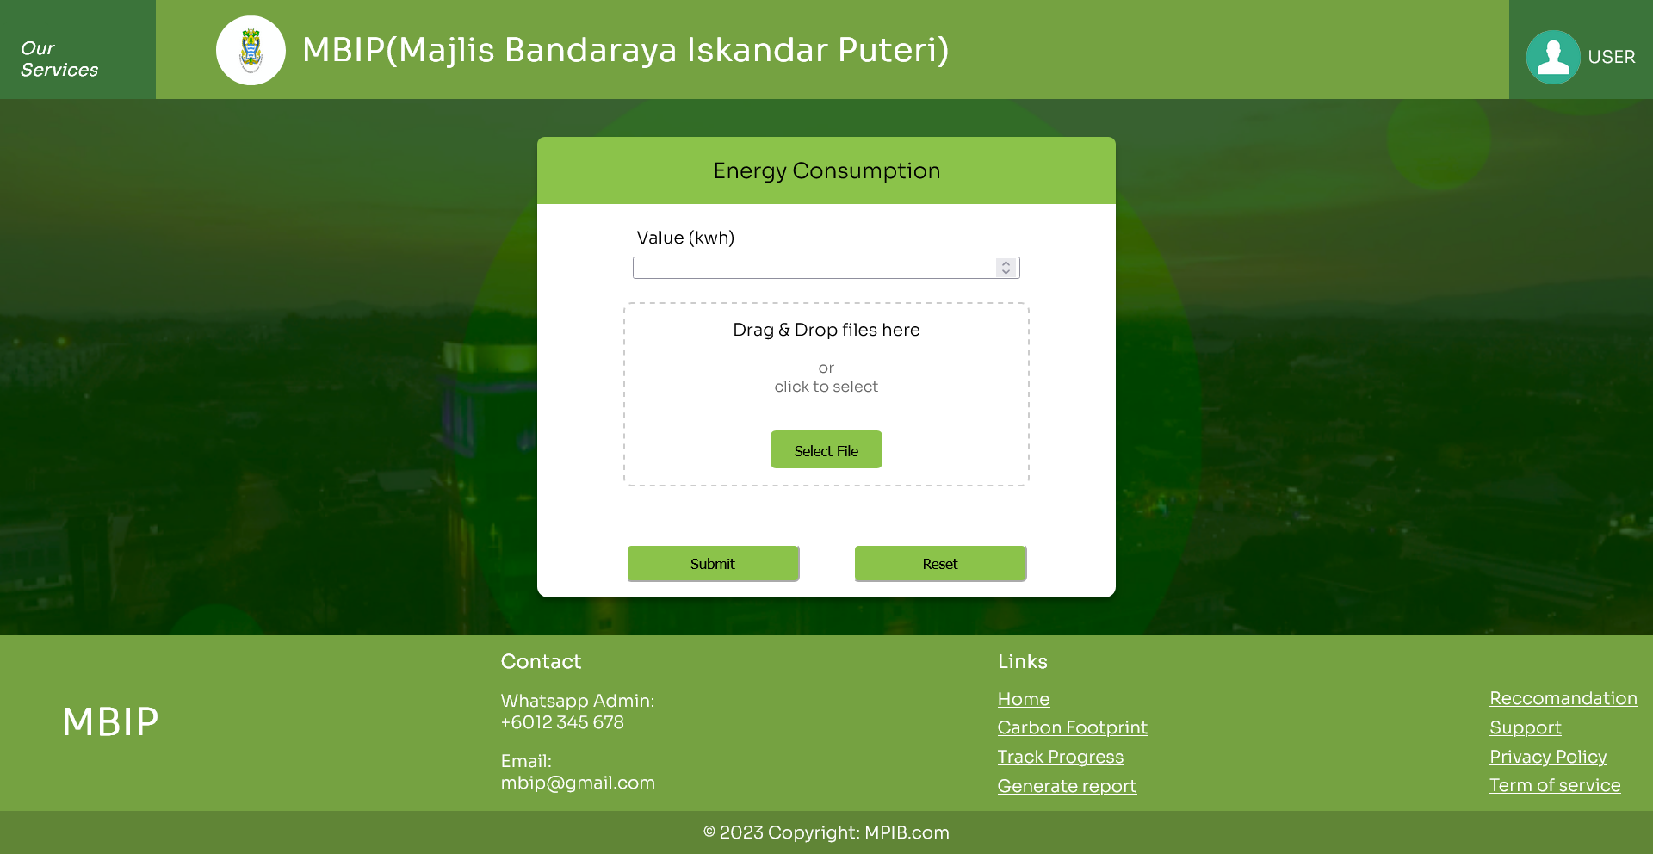



Add water consumption

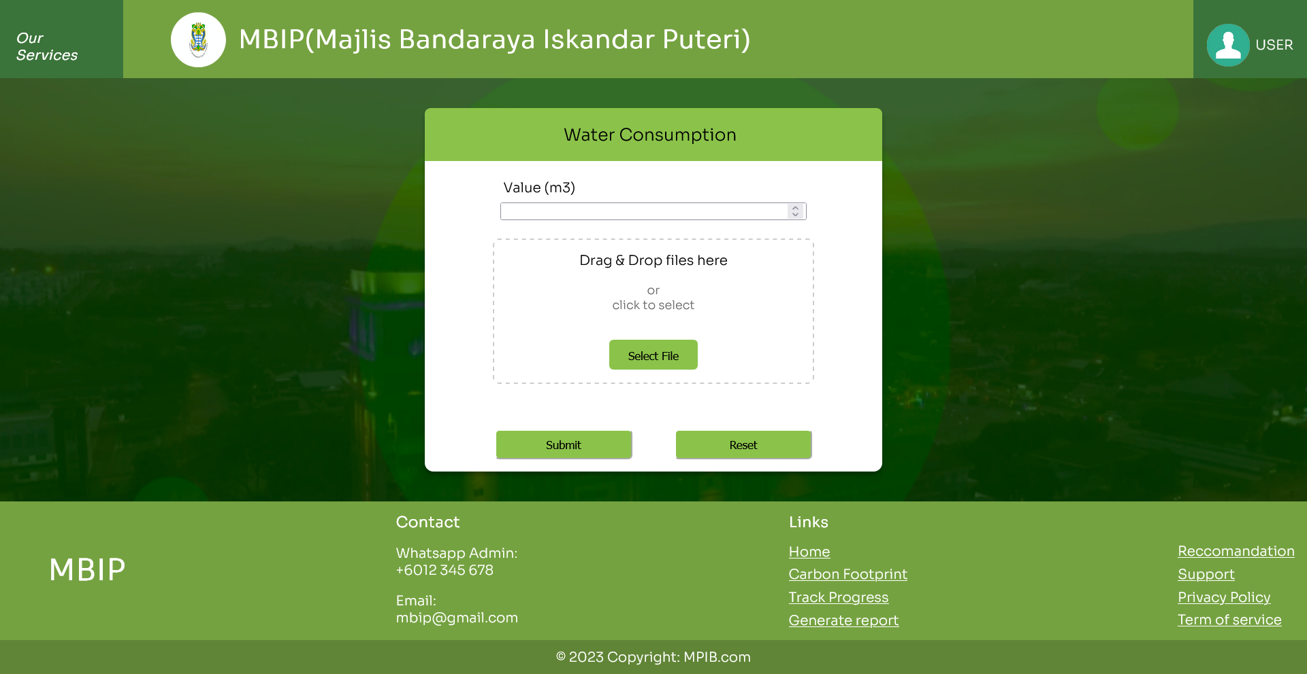



View bills

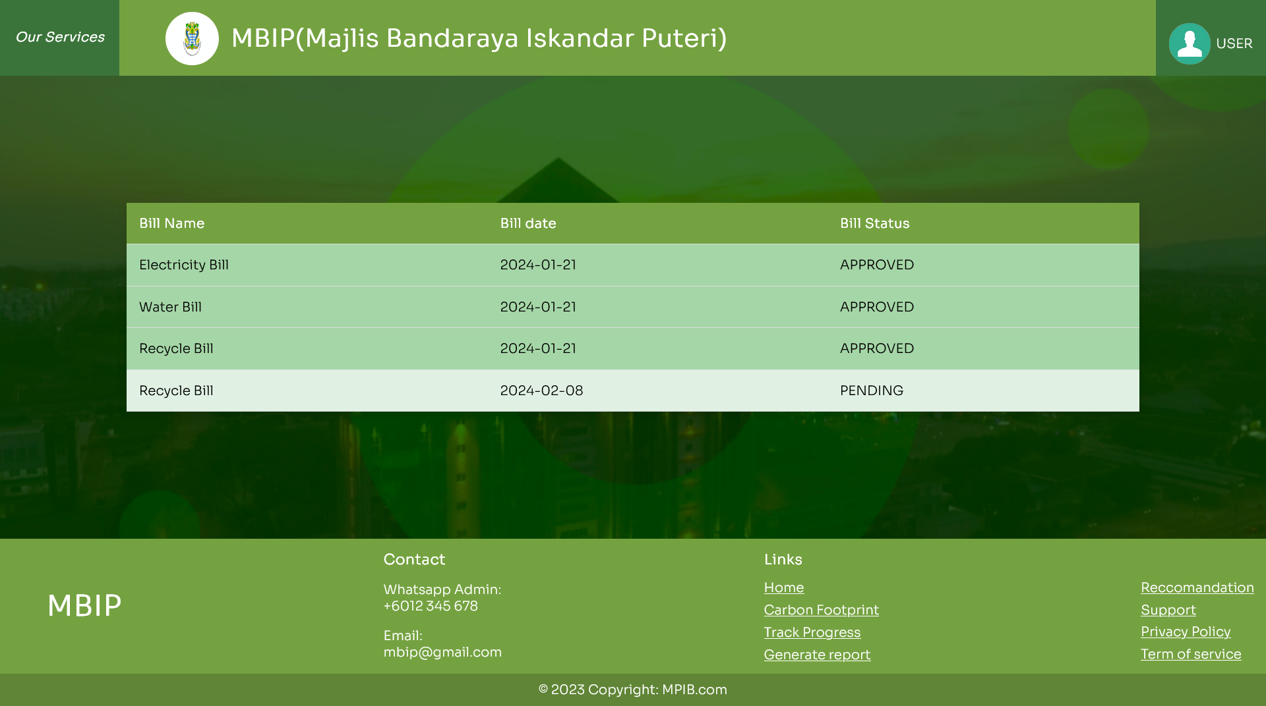

View carbon report

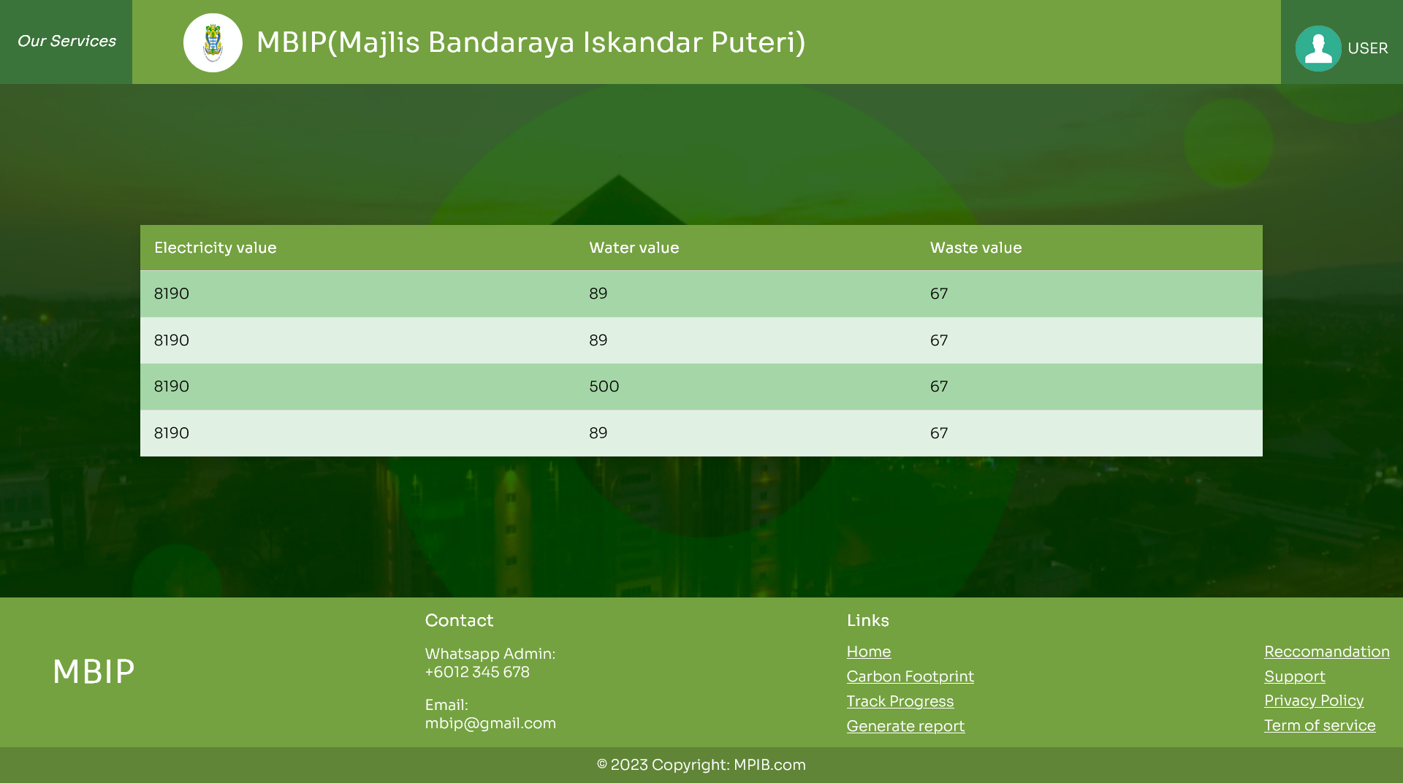

View activities

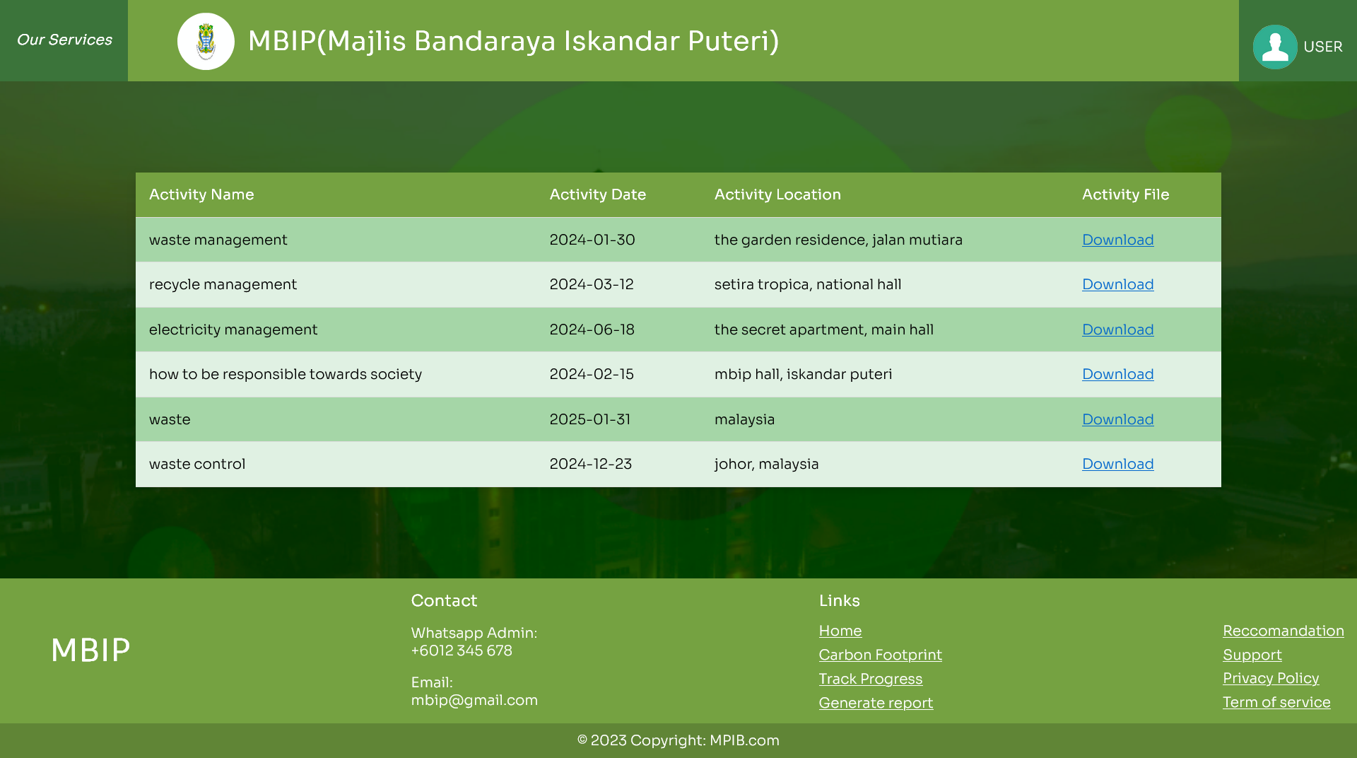

Reflection

Abdullah (A21EC0243)

Leading the recycling efforts in the MBIP carbon footprint management project has been a challenging yet fulfilling experience. Collaborating with a dedicated team, we successfully integrated sustainable recycling practices, witnessing tangible reductions in carbon emissions. Navigating logistical challenges required creative problem-solving, fostering a culture of innovation. Working across disciplines enhanced my understanding of holistic sustainability. Overall, the project has been a professionally and personally rewarding journey, contributing to a more eco-conscious workplace.

Marzouq (A21EC0266)

Being responsible for the database and authentication aspects in the MBIP carbon footprint management project has been both demanding and gratifying. Ensuring the security and efficiency of data storage while implementing robust authentication measures has been a critical task. Collaborating closely with the development team, we successfully established a reliable database infrastructure and secure authentication protocols. Overcoming technical challenges has deepened my understanding of system architecture and cybersecurity. This experience has been instrumental in contributing to the project's overall success, emphasizing the pivotal role of database management and authentication in a complex system.

Daniyal (A21EC0278)  
  
Managing the water conservation aspects and overseeing the UI/UX design in the MBIP carbon footprint management project has been a dynamic and fulfilling role. Implementing water-efficient practices aligned with project goals required strategic planning and collaboration. On the UI/UX front, translating user needs into intuitive designs has been a creative and rewarding process. Working collaboratively with diverse teams, we successfully integrated water conservation measures seamlessly into the system while enhancing the user experience. This dual role has provided a unique blend of environmental impact and user-centric design, contributing to a more sustainable and user-friendly project outcome.

Arshad (A21EC4007)

Being responsible for file uploading and managing the energy aspects in the MBIP carbon footprint management project has been both technically challenging and highly impactful. Implementing efficient file uploading mechanisms required careful consideration of data integrity and system performance. Simultaneously, addressing energy-related concerns demanded a strategic approach to optimize resource usage. Collaborating closely with development teams, we successfully streamlined file uploads, ensuring a smooth user experience. Additionally, our efforts in energy management have contributed to a more sustainable system architecture. This role has underscored the critical connection between technical solutions and environmental impact, highlighting the importance of mindful energy consumption in the project's overall success.

Saleh (A21EC9147)

Leading the activity management component in the MBIP carbon footprint management project has been both dynamic and fulfilling. Responsible for overseeing and optimizing various activities, the role required strategic planning and collaboration across teams. Balancing efficiency with environmental impact, we successfully implemented measures to minimize the carbon footprint of daily operations. Collaborating closely with diverse stakeholders, the role involved ensuring that activities align with sustainability goals. This hands-on responsibility has provided a comprehensive understanding of the practical implications of our project, emphasizing the importance of mindful activity management in achieving broader environmental objectives